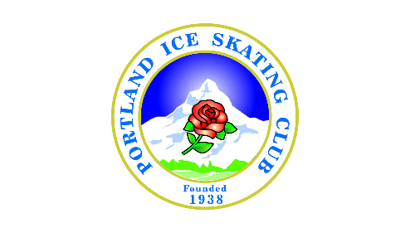
First in Oregon

Mission: Promote and expand the Sport of Figure Skating on Ice in Oregon.

4840 SW Western Avenue Suite 100
Beaverton, OR 97005
www.pisc.org

Membership Categories and dues from 7/1/2018 to 6/30/2019.
All levels of PISC membership class includes:

- U.S. Figure Skating Magazine (one per family)
- Participate in all U.S. Figure Skating sanctioned events
- Coverage under U.S. Figure Skating sports accident insurance policy
- Certificates of accomplishment for passing U.S. Figure Skating Tests
- Gold Pin for passing Senior tests (for Full Membership class only)
- Member right to vote (13 years & older)
- Participation in any Club social functions, exhibitions, and special events (a nominal fee may be applied)
- All levels of membership class dues are not transferable

Note: A Parent and/or legal guardian is required to sign up membership for any member under 18 years of age in all Membership Categories.

- Honorary Membership - $0

- Officials Membership - $60
- U.S. Figure Skating appointment is required

- Full Membership - $110; Additional family members can join for additional of $90.00 each

- Introductory Membership - $60; Additional family members can join for additional of $50.00 each
- One time membership to the skater who have never previously been a Full and/or Individual member of U.S. Figure Skating.

- Parent and/or Legal Guardian Membership - $35
- Parent and/or legal guardian of a member who is under 18 years of age.

- Adult Membership - $80
- 21 years of age and up

- Collegiate Membership (4 years) - $100
- One time membership to the skater who enrolled in college as a Full-time student.

- Coach membership - $65
- Requires U.S. Figure Skating clearance and compliance.

- Alumni Membership - $65
- 21 years of age and up, minimum 3 years members of PISC previously.

- Associate Membership - $50
- Member belong to a home club other than PISC; NO voting right.

